Accuracy Inspection Advanced Corrosion Detection

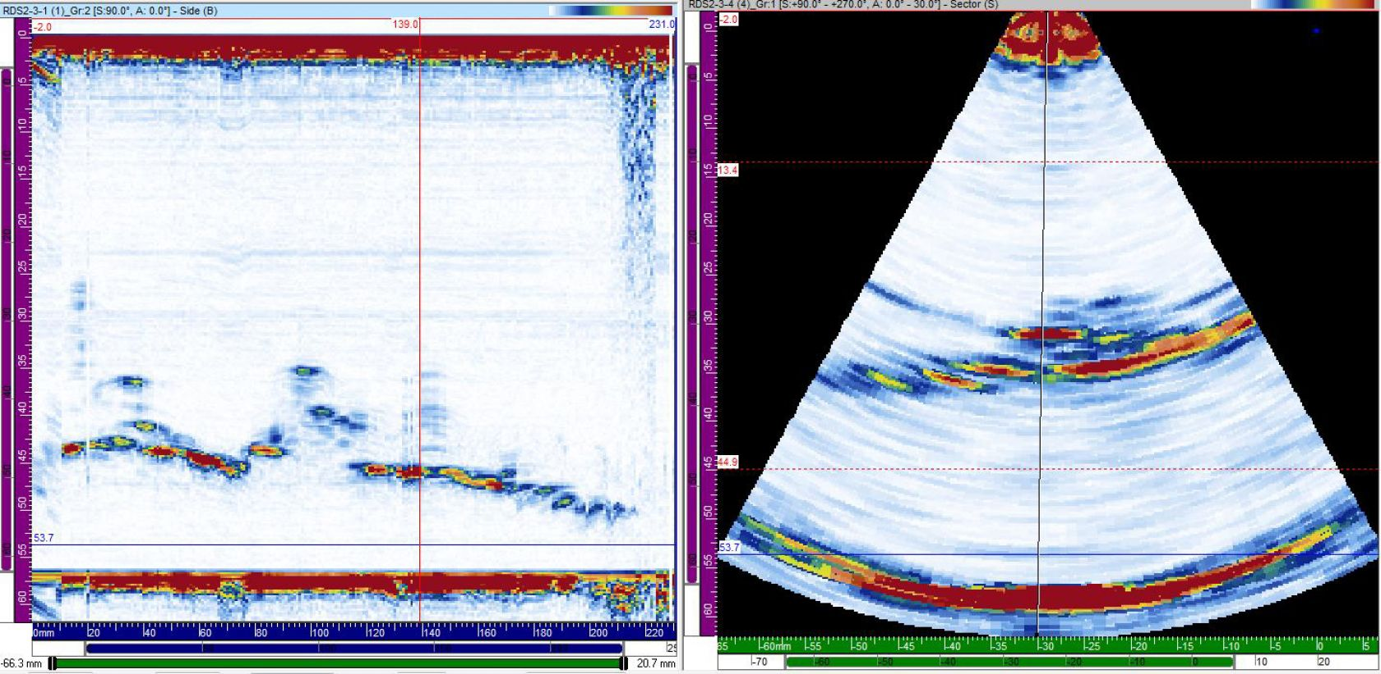
For many years the standard in corrosion mapping has been a zero-degree linear scan. In some cases, additional probes would be run in tandem to enhance detection of certain flaws. The picture on the left is a screen shot from a traditional scan depicting Hydrogen Induced Cracking. While this type of detection has been used reliably for many years now for this type of inspection, as well as weld and general corrosion mapping, we have incorporated a cutting-edge technology that changes everything. This technology is called Total Focus Method or TFM.
TFM focuses the sound waves within a specified area or box. That allows for greater detail and actual orientation of flaws or defects within a part. This method requires the use of specialized software to achieve the resolution and over all detection only TFM can achieve. All of this using a single transducer without the need for multiple probes or even multiple modes of UT to accomplish similar results. That keeps costs down per inspection as there is less equipment involved in the scan, eliminating many technical issues and interpretation errors by technicians.
The best way to demonstrate the difference between standard PAUT and TFM is using a similar flaw as above, Hydrogen Induced Cracking or HIC.
The image above shows the blistering but lacks the overall resolution to accurately reveal intra-blister cracking. The image below is of HIC using TFM.
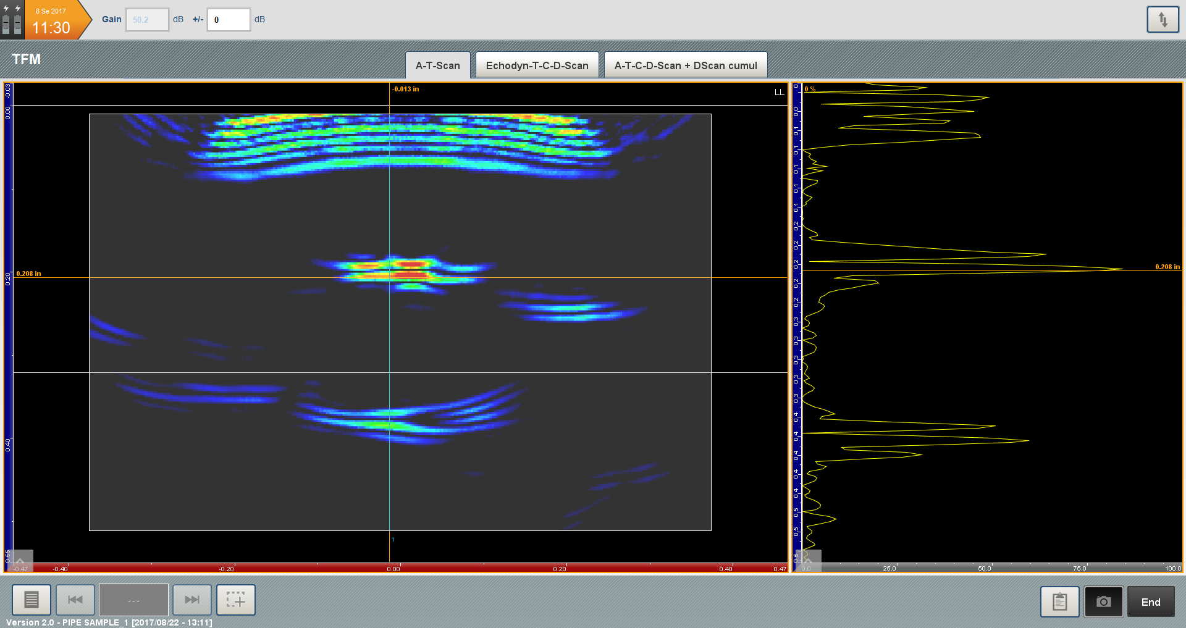
The above image was taken from a process pipe which contains HIC and heavy corrosion. Given the heavy pitting at the I.D. of the pipe locating HIC was very difficult with traditional PAUT methods. The software associated with TFM manages to not only detect wall loss, but also identifies HIC and intra-blister cracking easily and quickly. The benefits of this technology are stunning to say the least.

Of course, you still receive traditional views in the report as well as location and wall loss info, all with a single scan just as in the past.
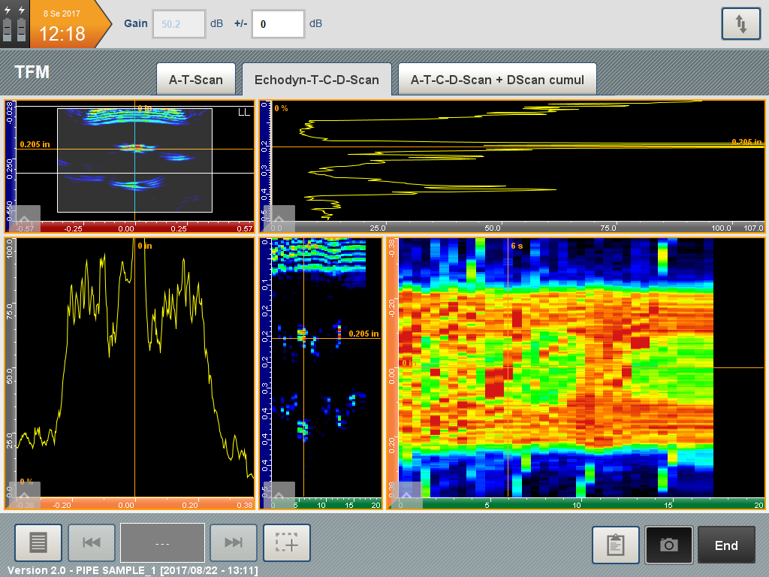
We are able to tailor our inspections to your specific needs and this technology can also be used for code compliant weld inspection eliminating the need for expensive and hazardous radiography. Give us a call to discuss your needs or setup a demonstration.
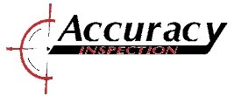
4924 S. County Rd. 1303
Odessa, TX 79765
(432)853-6274 or (432)381-5542
Mark@accuracyinspection.com

